🎬 Case Study: Netflix Recommendation Evolution
Stage 1: Genre & Popularity Rules (1990s)
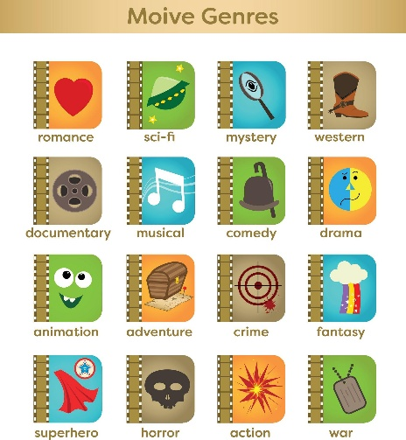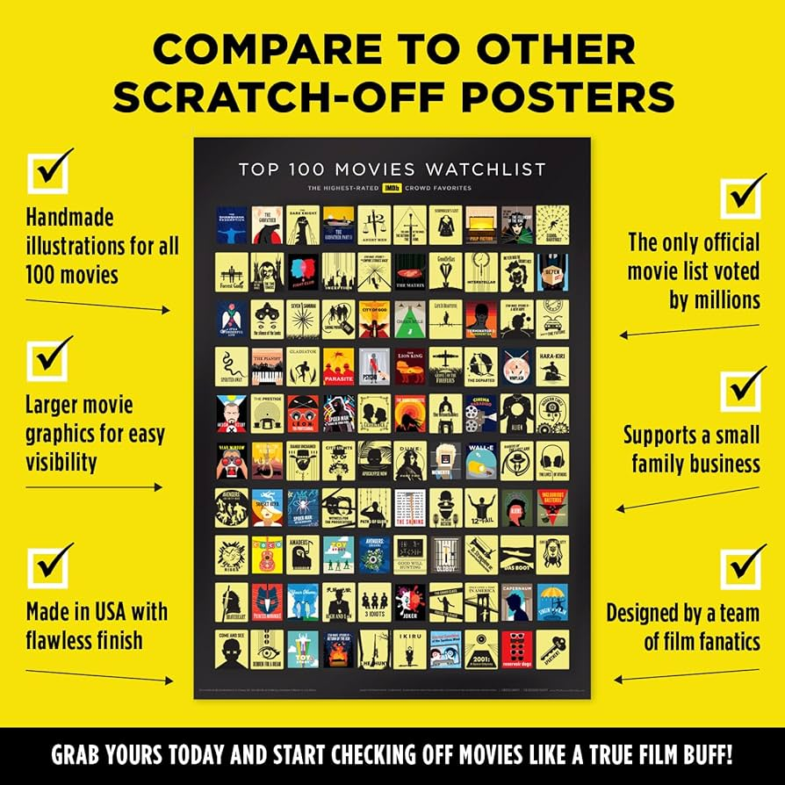

Early systems (including DVD-era recommendation logic at Netflix) relied on:
- Genre tagging
- Popularity rankings
- Simple business logic
Example Rules
IF user likes Action
THEN recommend more Action
IF movie is top 10 popular
THEN promote to most users
✅ Strengths
- Easy to implement
- Transparent
- No heavy computation
- Works with minimal data
❌ Limitations
- Very shallow personalization
- Assumes people only like one genre
- Cannot capture taste nuance
- Same “popular” movies shown to many users
It’s basically your restaurant rule system at scale.

Stage 2: Collaborative Filtering (2000s)
Core idea:
Users who behave similarly will like similar content.
If User A and User B both liked:
- The Matrix
- Terminator
And User A also liked Inception
→ Recommend Inception to User B.
This became famous during the Netflix Prize, which pushed collaborative filtering research forward.
✅ Advantages
- Much stronger personalization
- No need for manual genre rules
- Learns patterns from user behavior
❌ Problems
1️⃣ Cold Start Problem
- New user → no history
- New movie → no ratings
System has no basis for recommendation.
2️⃣ Popularity Bias
Popular items dominate recommendations.
3️⃣ Limited Context
It doesn’t know:
- Time of day
- Mood
- Device
- Cultural differences
It only knows co-preferences.

Stage 3: Deep Learning & Rich Features (2010s+)
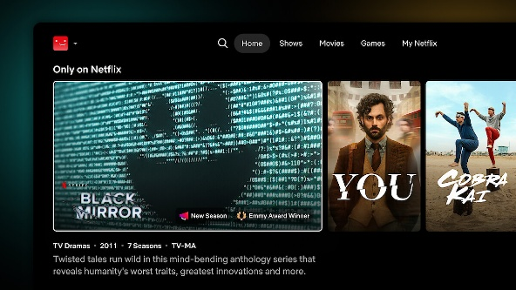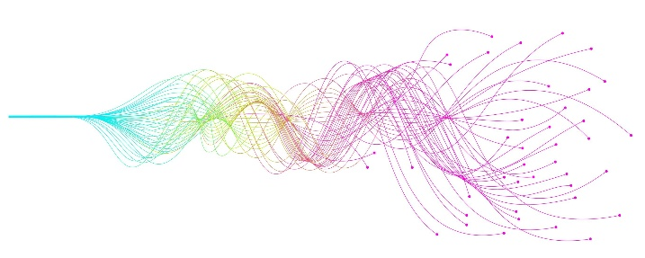

Modern Netflix systems combine:
- User watch history
- Pause/rewind behavior
- Time of day
- Device type
- Content metadata
- Viewing sequences
- Thumbnail testing
- Contextual signals
Now recommendations are:
Context-aware + personalized + dynamic
They also heavily use A/B testing:
- Different users see different ranking algorithms.
- Performance measured via engagement metrics.

